Getting started with
printing at Brookes

OBIS
Oxford Brookes Information Solutions
http://obis.brookes.ac.uk/
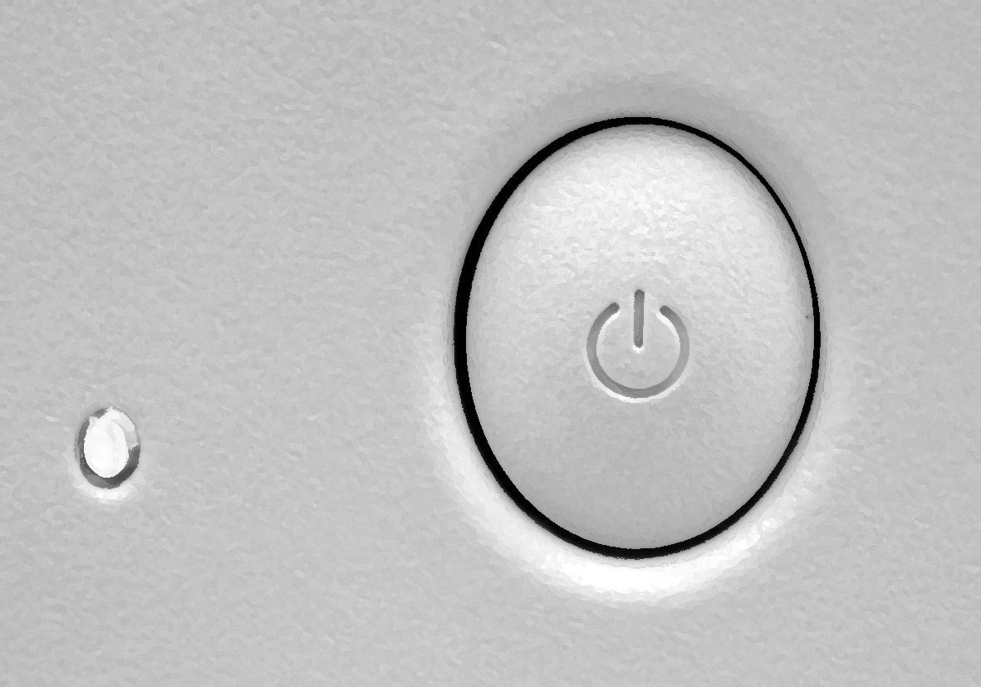
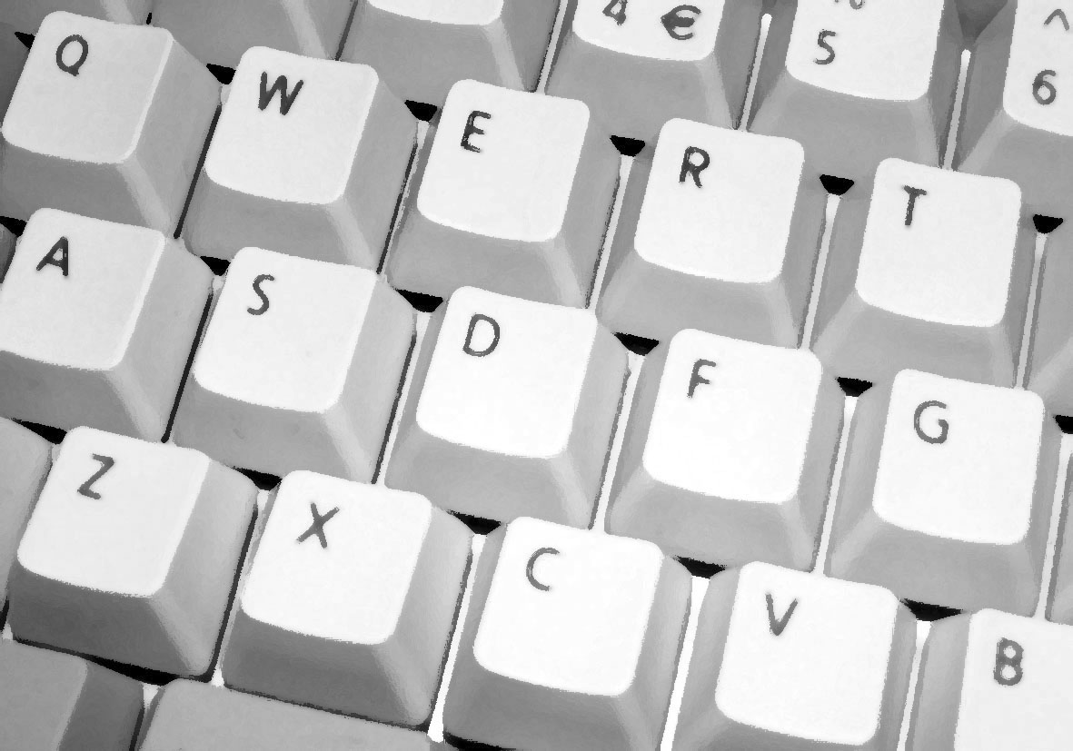
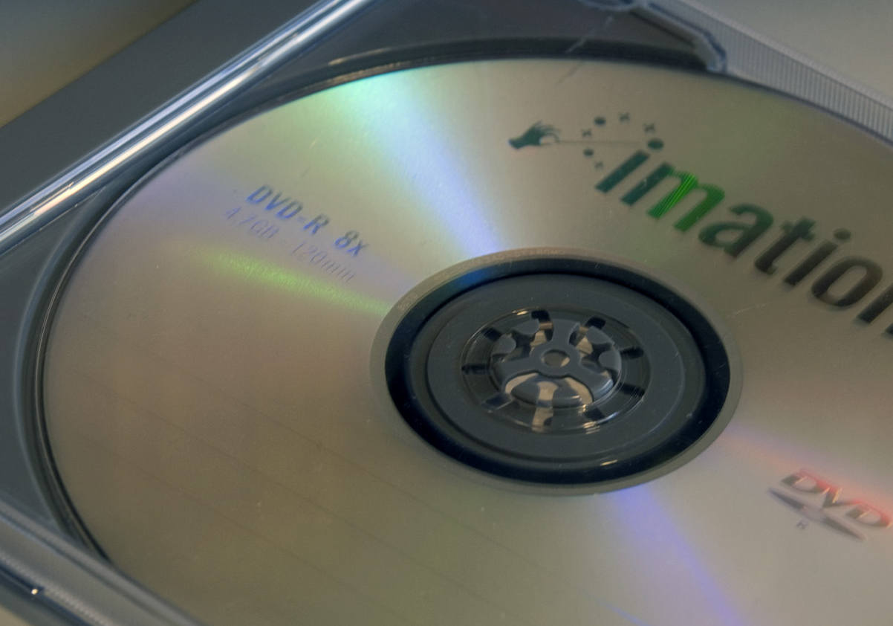
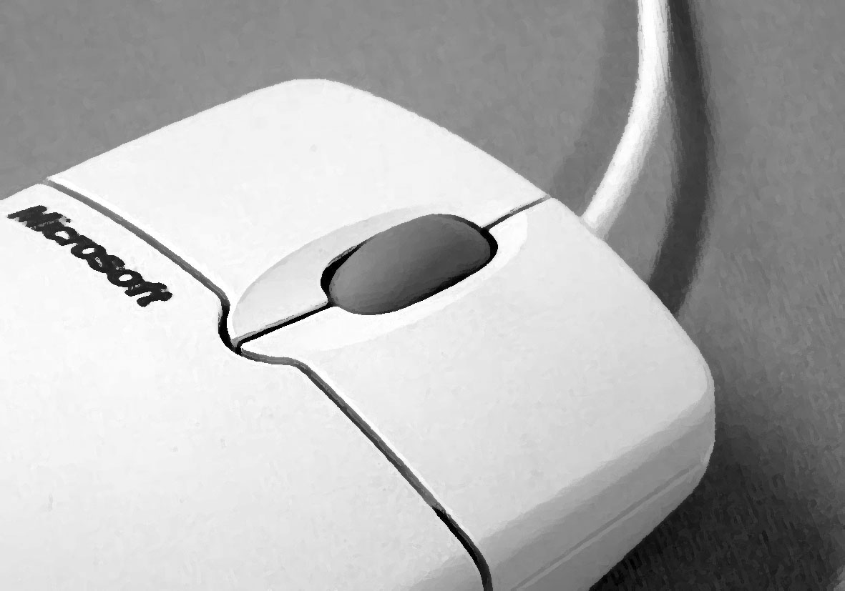
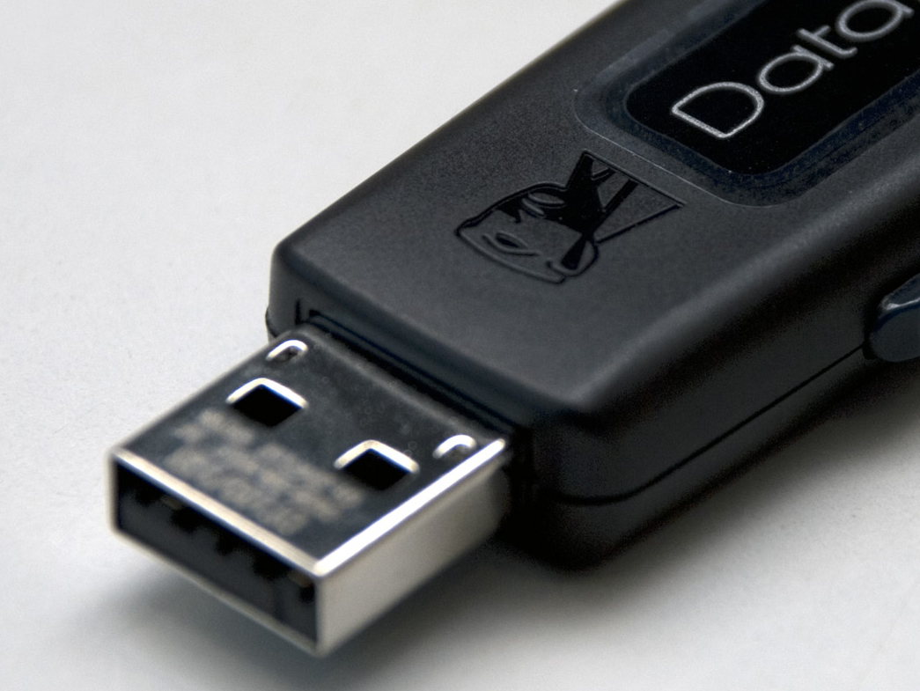

Conventions used in OBIS documentation

You will find the following conventions used in OBIS documentation.

type this text typed in bold courier shows you what to type on the keyboard.
filename text typed in italic courier is a placeholder for information you must provide. For example, if you were asked to type filename then you would type the actual name for a file rather than the word ‘filename’ itself.
h:\ text shown in courier but not bold text shows you what you will see shown on the screen of the computer.
<F3> angled brackets indicate a key on the keyboard.
<Shift/F3> indicates two keys to be used simultaneously by holding down the first key and tapping the second, e.g. hold down the Shift key and tap the F3 key.

Before reading this document, you should already be familiar with the following aspects of computing:

☑ Logging on to the Brookes PC network
☑ Accessing and using Windows
☑ Opening, saving and printing documents

Authorship
Originated by: | Graham Toon
Revised by: | Sue Austin

 | © Oxford Brookes University November 2026  Please look after the environment and either recycle, return or pass on this document
Contents

Avoiding the pitfalls 1
A word about applications 1
Converting to PDF 1
Before you print 2
1. Make sure there’s money in the bank 2
How do I check my balance? 2
How do I pay money into my account? 2
How much does it cost to print? 3
What about refunds? 3
How do I close my Charge Account? 3
2. Prepare your document correctly 4
How can I keep the file size of my document small? 4
What if my document contains images? 5
3. Plan ahead 5
Setting up and submitting a print job 6
1. Choose the right printer 6
2. Configure the printer settings 7
What options should I set? 7
How can I ensure my document fits on the printed page? 7
Printing multiple pages or copies to the plotters 7
3. Hit the Print button 7
Whilst the job is printing 8
Manage your printing 8
How do I check the status of my print job? 8
How can I cancel my print job? 8
When the job has been printed 8
Collect your printouts 8
When things go wrong 9
1. Error messages and what to do about them 9
Message: “Not formatted for A4” 9
Message: “Manual feed selected” 9
Message: “Insufficient funds available to print this job” 10
Message: “Number of pages estimated was zero” 10
2. Other common problems 10
Application issues 10
Document layout issues 10
Nothing comes out of the printer 11
My file is in the colour queue but it isn’t printing 11
3. Still having problems? 11

Avoiding the pitfalls

How do I print in colour? What application should I use to create an A1 poster? How do I select photo-gloss output? How do I print to acetate? How do I convert my files to PDF?
These are just a few of the many questions we get asked at our Service Desks. There are many different printing options at Brookes which give rise to many queries and problems.
This document aims to answer some of the most common questions and help you avoid the pitfalls so that you can print successfully first time round.

To begin with, each computer room has its own high quality black and white printer which prints double-sided (duplex) by default. In addition, all room PCs are configured to print to the central colour printers:
- Large format, roll-fed inkjet plotters with a choice of matt, semi-gloss or photo-gloss paper from A3 to A1 size. Located on Gipsy Lane Campus.
- Fast sheet-fed colour laser printers providing single/double-sided printing on A4 and A3 paper, as well as single-sided output onto A4 transparencies (acetates). Located on all three campuses.

A word about applications

If you want to produce posters larger than A3 size and you have little or no experience of graphics packages such as Photoshop and Illustrator, try creating the artwork in PowerPoint or Publisher.
Note: do not use Word for documents that exceed A3 (420 x 297 mm) size as they will not print.

Converting to PDF
If you are having problems printing your document from the application in which it was created, try converting it to PDF format then printing from Adobe Acrobat Reader. See the OBIS document How to convert files to PDF for more information.
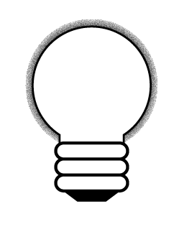
If you want to use the Brookes printers to print a document originated in an application on your home PC and not installed on the Brookes network, first convert it to PDF then print from Adobe (Acrobat) Reader. If you do not have any PDF conversion software, try downloading and installing a freeware utility such as PDFCreator or PDF 995.

Before you print

1. Make sure there’s money in the bank
Every student is allocated a Charge Account which is automatically debited whenever you send a document to print. At the beginning of each academic year students are given a free initial printing allowance. For 2011/2012 this is £1, which is equivalent to 20 free black & white pages. Make sure there are sufficient funds to cover the cost of your printing.

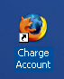
How do I check my balance?
From the Windows desktop, double-click on the Charge Account icon
In addition to your balance, there are also options for you to print a statement of the day’s transactions, or review the current printing costs.
Your balance is also shown on the banner which accompanies your printouts. Two figures are displayed, University funded and Personal account. Your current balance is the total of these.

How do I pay money into my account?
There are two ways to do this:
- Credit your Charge Account in person at the OBIS Computer (Gipsy Lane) and at the Headington, Wheatley and Harcourt Hill libraries.
- Pay online using a debit/credit card at:
https://tl.brookes.ac.uk/admin/chact-login.html

How much does it cost to print?
The table below gives the printing charges for the academic year 2011-2012.

Printing charges as of 01/09/11
Paper size | Local black & white printing (in computer rooms) | Central Colour Printing
Paper size | Local black & white printing (in computer rooms) | Colour A4 - A3 Printer | Matt plotter | Semi-gloss plotter | Photo-gloss plotter
A4 (standard paper) | 5p | - | - | - | -
A4 (duplex printing) | 8p | - | - | - | -
A4 (high quality paper) | - | 15p | - | - | -
A4 (high quality duplex printing) | - | 25p | - | - | -
A4 (high quality gloss printing) | - | 25p | - | - | -
A4 (high quality duplex gloss printing) | - | 35p | - | - | -
A4 OH Transparencies | - | 80p | - | - | -
A3 (high quality paper) | - | 30p | £1.50 | £3.00 | £4.00
A3 (high quality duplex printing) | - | 45p | - | - | -
A2 | - | - | £3.00 | £4.00 | £5.00
A1 | - | - | £4.00 | £6.00 | £8.00

What about refunds?
Refunds can only be given for print jobs that fail as a result of network or system errors. Under no circumstances will refunds be given for users’ own errors. If you think you may be entitled to a refund, talk to the Service Desk staff. Please also see the warning about changing printer settings on page 7.

How do I close my Charge Account?
You can close your Charge Account and withdraw the entire personal account balance on production of your valid student ID card at the OBIS Computer Shop.

2. Prepare your document correctly
Careful document preparation will help you avoid many printing problems. Use the following advice to ensure your document is ready for printing.

How can I keep the file size of my document small?
Documents containing large graphics files cause huge bottlenecks in print queues. The larger your print file, the longer it will take to process and output (bad news if you have a tight deadline to meet!). With large files there is also a far greater risk of causing a printer error, which means that your document will not be printed correctly or may not print at all. Keeping file sizes as low as possible means:
- you get your printouts faster;
- your documents are more likely to output correctly first time round so you don’t have the expense of re-printing them;
- other users with smaller print jobs are not kept waiting while your files are being processed.
Please note: large print jobs (over 130Mb) are automatically placed at the bottom of the printer queue and are only printed when all smaller jobs have been printed, you will be informed via email. Also files created which are over 400Mb in size will be automatically rejected by the print queues, and again you will be informed via email.
The following guidelines will help you to create more compact files that will print quickly and reliably:
- Make sure images are scanned in at 100-200 ppi maximum. There will be no visible benefit from using resolutions higher than these values as the printers are not capable of reproducing the extra detail. Using too high a resolution simply increases the file size and greatly slows down the printing of the image.
Remember: the higher the resolution, the larger the file size.
- Existing images that exceed 200 ppi should be resized in an image editor such as Photoshop or Paint Shop Pro. For information on how to do this, consult the Online Help or see the relevant OBIS document.
- Scanning software utilities (TWAIN drivers) allow you to specify the printed dimensions of the image. If the final print dimensions are going to be smaller than those of the original, you can significantly reduce the file size by specifying these dimensions prior to scanning. For example, if your original is 297mm x 210 mm (A4) but you anticipate printing the image at roughly half that size, set the ‘output’ size to 210mm x 148.5mm (A5).
- If you are creating a poster or montage from scratch in Photoshop or Paint Shop Pro, select an appropriate document resolution when the New/New Image dialog box appears. Select a resolution of between 100 – 200 ppi, ensuring that the resolution of the images you paste or import into the document matches this value.
- When scanning, choose the correct colour depth. For full colour images, always select 24-bit and not the 42-bit (HiFi colour) option offered by some scanners. Similarly, for greyscale images, select 8-bit grey (not 14-bit grey). If you plan to print in black and white, scan colour images in as 8-bit greyscale.
The greater the colour depth, the larger the file size.
- Before printing documents that contain multiple layers (e.g. Photoshop, Paint Shop Pro and Illustrator files), flatten the document into a single layer. For information on how to do this, consult the Online Help.

What if my document contains images?
By default, Word and PowerPoint embed imported images into the document so the images travel with the document. When you import an image into a page layout program such as InDesign, Pagemaker or Quark, however, the image file is not added to the document. Instead, the program maintains a link to the original, full resolution graphic and uses this when the document is printed. It is important not to break links to external image files, since without access to the original file, the low-resolution proxy version you see on screen is used for printing instead. To avoid breaking links and compromising image quality, make sure that whenever you move a document to another location for printing, you move any linked graphics at the same time.

3. Plan ahead
Since print queues get very large at peak times when submission deadlines are looming, it is well worth planning ahead and sending your documents to print before everybody else sends theirs. If permitted, consider submitting your assignment electronically (in PDF format) as this obviously avoids using the printers altogether.

Setting up and submitting a print job

1. Choose the right printer
Use the table below to help you select the most appropriate printer for your needs.
Device name | ISO Paper sizes | Paper type and quality | Colour or  black & white? | Suggested uses
Computer room printer denoted by name of the computer room you are in e.g. FHG06 | A4 (420 x 297 mm) single-sided or duplex | Standard quality (80 gsm) white uncoated | Black & white | General black and white printing
GLA4A3Colour*  WA4A3Colour*  HHA4A3Colour* | A4 (420 x 297 mm) A3 (420 x 297 mm)  single-sided or duplex | High quality white coated (130 gsm) | Colour | Final dissertations and reports, booklets, small posters and flyers
GLA4Gloss*  WA4Gloss*  HHA4Gloss* | A4 (420 x 297 mm)  single-sided or duplex | High quality white coated (220 gsm) | Colour | Final dissertations and reports, booklets, small posters and flyers, photographs.
GLA4Acetate*  WA4Acetate*  HHA4Acetate* | A4 (297 x 210 mm) | Transparency | Colour | OHPs
Matt_Plot⁺ | A3 (420 x 297 mm)  A2 (594 x 420 mm)  A1 (841 x 594 mm) | White matt coated | Colour | Line and CAD drawings, draft printing of posters and images on matt paper
SemiGloss_Plot⁺ | A3 (420 x 297 mm)  A2 (594 x 420 mm)  A1 (841 x 594 mm) | White, semi-gloss paper | Colour | Photographic and computer-generated images, e.g. posters, and montages, on semi-gloss paper
PhotoGloss_Plot⁺ | A3 (420 x 297 mm)  A2 (594 x 420 mm)  A1 (841 x 594 mm) | White, high-gloss photo paper | Colour | Best quality reproduction of photos and other images on full gloss paper
* Prefix denotes printer location: GL = Gipsy Lane Campus. W = Wheatley Campus. HH = Harcourt Hill Campus.
⁺ Located on Gipsy Lane Campus

You can have your dissertation printed and bound by the Print Unit, located in the Media Centre on Gipsy Lane Campus. The Print Unit accepts hard copy originals or files in PDF format. Contact them for more details.
2. Configure the printer settings
Having selected the right printer, you must set it up according to your needs.

What options should I set?
Make sure you set the following:
- Paper size – A4, A3, A2 etc.
- Orientation – Portrait or Landscape.
- Page range and number of copies.
- Any other options such as double-sided (duplex).

How can I ensure my document fits on the printed page?
It is not possible to print right up to the edge of the paper. For each paper size, there is a printable area within which artwork will be printed and a small, non-printable area around the edge of the paper. To avoid cutting off part of your artwork, use the following guidelines.
- Make sure you select a paper size which matches that of your document.
- If the application provides one, use the print preview facility. This will show you at-a-glance whether or not all of the artwork fits on the selected paper size.
- If the artwork is being cut off, either choose the next paper size up or check the Scale to Fit (sometimes called ‘Reduce to Fit’ or ‘Fit to Page’) option, which will be found in one of the print dialog boxes.
- If there is no print preview facility it is strongly recommended that you routinely check the Scale to Fit option as a precaution. This is especially important if the outer edges of your artwork are near to the edge of the page.
Important: the Scale to Fit option scales the artwork up or down so that it fits within the printable area for the specified paper size. If your document must be printed at a particular scale, do not check this option as the scale will be incorrect. Instead, print at the default 100% scale and, if necessary, use a different paper size.

Printing multiple pages or copies to the plotters
Please note that if you are sending print jobs to any of the plotters which have multiple pages, or you want to print multiple copies of one page you MUST send them one page at a time, or the print job will be rejected and you will be informed via email. This is to enable us to keep the large sized print jobs to a minimum and ensure that each plotter job has a header on each page to clearly identify your work.
IMPORTANT! The drivers for each plotter and printer have been set up to give optimum results. Do not, therefore, tamper with any of the settings in the printer preferences or printer setup dialogue box. If you are printing from Photoshop or Illustrator, do not change the colour management settings in the Print dialog box. OBIS cannot accept responsibility for any unexpected results that may occur if you change these settings.

3. Hit the Print button
Having configured your selected printer correctly, send your document to print. When using the central colour printers during busy periods, bear in mind that there may be a considerable delay before you can collect your printouts. Keep checking the progress of your print job using the print queue monitor. See the section Manage your printing (below) for more details.

Whilst the job is printing

Manage your printing
Having sent your document to print, you can check its status (e.g. its position in the print queue) and, if necessary, cancel the job, provided it hasn’t gone beyond the point of no return!

How do I check the status of my print job?
To view the status of jobs sent to the central colour printers, do one of the following:
- From the Windows desktop, double-click on the Colour Print Queues icon. This will show the number of jobs in the spooling and printing queues.
- Search for Printing on the OBIS website at: http://obis.brookes.ac.uk/

How can I cancel my print job?
Depending on the location of the printer, do one of the following:
- For central colour printing:
- On the Desktop, double-click on the Colour Print Queues icon.
- Locate your print job in the queue.
- Select it and then click on the Delete Job(s) menu.

- For local (computer room) printing:
- Click on the Start button in the bottom left corner of the screen.
- Choose Printers and Faxes.
- Double-click the icon for the printer you are using (e.g. \\brookese1\FHG06 if you are printing in room FHG06).
- In the list, click the document you want to cancel.
- From the Document menu, choose Cancel.

When the job has been printed

Collect your printouts
Jobs sent to the central colour printers can be collected from the following places:
- Gipsy Lane: pigeon holes at the OBIS Computer Shop.
- Wheatley: Library.
- Harcourt Hill: Library.

When things go wrong

1. Error messages and what to do about them
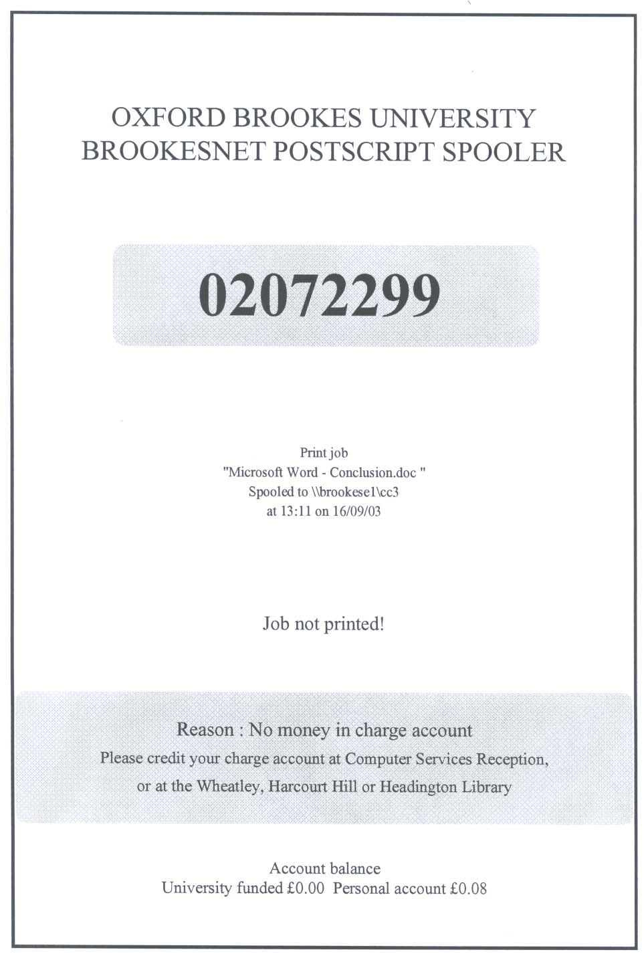
Sometimes you will get a cover sheet out of the printer with a message that explains the problem.
Message - Why job won’t print
Student/Staff ID
File Name / Internet address
Account balance

Message: “Not formatted for A4”
Cause:
You tried to print a document that has a page size other than A4. Normal paper size is A4 (210 mm x 297 mm). Word jobs will not be printed if they are not formatted for A4 paper. Check all documents created on computers outside the University for paper size before printing.
Solution:
Resize the document to A4.

Message: “Manual feed selected”
Cause:
You tried to print a document that’s set up to print from a printer’s manual feed tray. Jobs will not be printed if they are set up for the manual feed tray. Check all documents created on computers outside the University for the paper source settings.
Solution:
- From the Edit menu, choose Select All.
- From the File menu, choose Page Setup.
- Click on the Paper tab.
- Set both the First page and Other pages fields to “Default tray (Automatically Select)”.
- Click OK and check your document for any layout changes.

Message: “Insufficient funds available to print this job”
Cause:
You tried to print a document when you haven’t got enough money in your Charge Account.
Solution:
Pay in sufficient funds to cover the cost of the print job. See the section How do I pay money into my account.

Message: “Number of pages estimated was zero”
Cause 1:
- You tried to print a range of pages in Word. When you specify a range of pages in Word, the page numbers you use should refer to the page numbers you have given the document. For example, if the status bar displays Page 6 Sec 3 8/11 the current page for printing purposes would be page 6 and not page 8.
Solution:
Specify the current page number not the absolute page number.
Cause 2:
- You tried to print a web page in a web browser.
Solution:
Try doing a Print Preview of the web page in the browser, waiting for the page to reload and then choosing the Print option from that screen. If that fails, you could save the web page text and graphics and print it from another application because some web pages are written in such a way that they just won’t print on our networked printers. Read Getting started with the Internet (available on our website) for further details.

2. Other common problems

Application issues
The application you are printing from sometimes causes problems. If you suspect this is the case, try converting the document to PDF format then printing from Adobe Reader. See the OBIS document How to convert files to PDF (available on our website) for more information.

Document layout issues
Incorrect document formatting can lead to printing problems. Word users can find information about the use of indents, tabs, page numbering, spell checking etc. in the document Getting started with Word 2003 or Word 2007 and also the Word 2003 or Word 2007 QuickRef documents. These documents are available on the OBIS website.

Solutions:
- Don’t use the space bar to line up text. Use tabs, indents or tables instead.
- Don’t use the <Enter> key repeatedly to get to the bottom of a half full page. Insert a page break instead.

Nothing comes out of the printer
You sent your work to print, but nothing comes out of the printer.
Causes and solutions:
- Make sure you have sent it to the correct printer.
- If you are printing to the local printer is it working, are other people using it?
Is there a long queue? Is the printer displaying an error message?
Is there paper in the trays?
- If you are printing to the central printer are you looking in the correct racks?
Has your printout been filed under another number? Is there a long queue?
- If you are printing to the plotters did you send a multi page document or copies of one page? Only one page at a time can be sent. You will be informed via email if you have done this.
- If you are printing to the plotters did you format the paper size in the application you are using, and within the printer properties? You may get an email sent to you with an error message similar to this one - “This printer sgplot can not print this paper size A4 so job has been aborted”.
- If you are printing to the plotters did you send a file to the printer which was over 400Mb? You will be informed via email if you have done this.

My file is in the colour queue but it isn’t printing
Possible cause:
Your print file may be too large. Is the size of your file as it appears in the print queue over 130MB? To ensure that the printing service runs smoothly, priority is given to smaller files; so the printing of files which are unnecessarily large might be delayed.
Solution:
Try reducing the size of your file. For guidance on how to do this, see the section Prepare your document correctly. There are many problems that can occur if you d o not follow the correct procedures for creating and printing your work so please follow our recommendations.
If your document was created outside Brookes (for example on your computer at home), it may use fonts that are not installed on the computer room network. To avoid font substitution, convert the document to PDF before bringing it into the University to print.

3. Still having problems?
If you are unable to resolve a printing problem yourself, help and support are available from the OBIS Service Desks.

Also for printer hardware problems (in computer rooms), for example, an error message on the printer console or the printer runs out of toner/paper, and for printer software problems, contact the Service Desks.

Email: servicedesk@brookes.ac.uk or telephone 01865 483311, or drop by and visit one of the staffed Service Desks based on each campus.

